

**Home Healthcare**

Scope Document / Concept Brief

Lone Werness Bekkeheien, 1180241

Aleksander Asp, 1180184

[08.10.18 and 1.0]**Overview of Concept**

[*Describe your game in two sentences. Include the main objective, genre, story, platform, and any other relevant information.*]

**The game will depict the tasks and reality of home care services. The player assumes the role of a direct care worker which has to manage a series of case scenarios with patients who have different conditions. The game will be social, multiplayer and will run on mobile devices.**

**Description**

[*Describe the actual game to the future players. Include the genre definition. Introduce the target audience. Present the story/narrative, general visual style (look and feel) and game environment. Encompass all the key elements that define the core game play by describing exactly what the player does and sees (for instance, what is he going to do/see after he hits the start button). Describe the characters*.]

**Players will take on the role and tasks of a person working in home care. This includes driving around town to visit and check up on the players patients. The patients will have different needs and conditions and the player must be able to tend all of these needs. To learn how to tend to more serious needs, the player must take tutorials in the Care Office. The game has a 3D environment, created in Unity, which will have a natural feel. Players start in the Care Office, receiving information about the classes in the office, their new company car and their first patient.**

**Key features:**

[*What will be the unique characteristics of your game?*]

**The game will provide a light and entertaining approach to the very sensitive process of caring. It will allow future carers to understand the requirements of the process but, at the same time, will allow current carers to identify themselves in the game. The game will continuously track the user’s abilities, keeping up and staying “half-a-step” in front of player performance. The game provides a natural interaction and little-to-no learning curve considering that the end user might have different social and cultural backgrounds and technical literacy.**

**The game will provide the player with insight in home care services and teach players how to take action as a carer, according to specific patient conditions.**

**Core Gameplay Mechanics**

[*Describe the most important mechanics of your game*]

**The most frequent action in the game will be to point, click and drag on game objects to fulfill the patient’s needs. For instance, to give a patient the medicine the player must click on the medicine and then on the patient, or just drag the medicine to the patient.   
This mechanic, point, click and potentially drag, will also be used for driving, cooking, dressing patients, helping with seizures and communicating with other players as well as NPCs.**

**The player does not have a health or energy bar, but has a patient-satisfaction bar. This bar, along with the time used for each level, determines the score the player receives.**

**Technical Specification**

[*List all the technical requirements for development and delivery (including software and hardware resources). List the target platform(s). If you intend multiplayer support, indicate that as well*.]

**The game will be developed in Unity and will run in mobile devices.  
To fulfil the technical requirement for software we will be coding in C Sharp together with Unity.   
The game is intended to work on different mobile devices.  
The game will also include multiplayer support using Unity’s built in multiplayer networking and the associated High Level API.**

**Concept art**

[*To the extent possible, include bits of visual and audio art (assets)*]

**‘Asset store’ will be used to get the general game design of humanoids, surroundings, Care office/houses and cars. More specifics will be done with game objects, coding etc.**

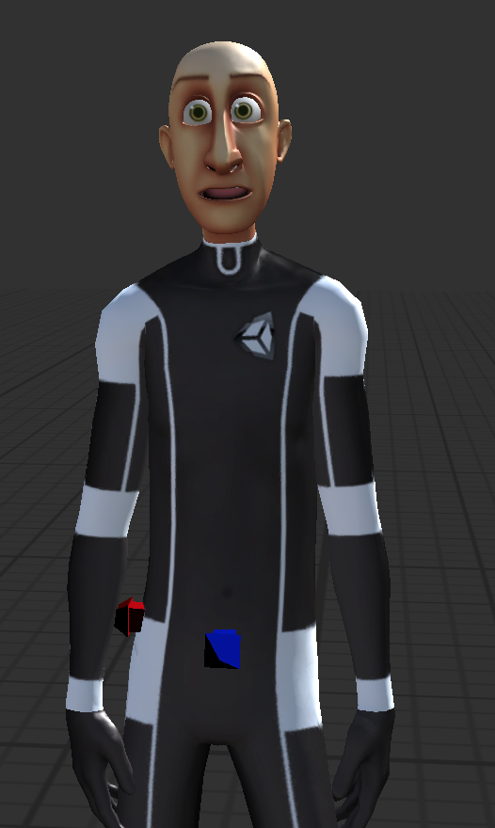

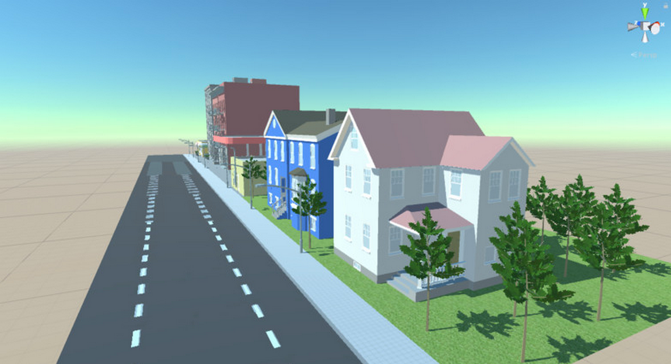**Product Backlog**

[*Describe all requirements that will establish the successful completion of the project. Use “user stories in the following format: As a (role) I want (something) so that (benefit)*].

As a Player…

**I want the game to keep me entertained so that I enjoy that time**

**I want to be able to play in short spans of time so that I can use the (short) moments I’m not busy**

**I want to attend the care Office courses to learn how the game works.**

**I want to give my patients the right medicine to get maximum score.**

**I want to dress my patients in the correct manner to get maximum score.**

**I want to prepare the correct food for my patients to get maximum score.**

**I want to press the pop-up buttons as fast as possible to get maximum score.**

**I want to finish my route as fast as possible to get maximum score.**

**I want to play with other players and complete my objectives as fast as possible to get maximum score.**

As a Future Carer…

**I want to know what are the tasks that a carer normally does so that I’m prepared for those later.**

**I want to know the possible situations are when people require care.**

**I want to know how home care services work.**

**I want to know what to do when a patient has a seizure.**

**I want to know what to do when a patient has a stroke.**

**I want to know how to a help a physically challenged patient in daily activities.**

**I want to know how much time I can/should spend with each patient.**

**I want to experience cooperating with other carers.**

As a Carer…

**I want to be able to play with other Carers so that we can exchange information about our activities**

**I want to be able to support other Carers so that we can create a social community**

**I want to be able to play with my co-workers to learn from their experiences as home carers.**

**I want to be able to play with my co-workers to learn teamwork skills.**

**I want to refresh my knowledge on stroke**

**I want to refresh my knowledge on physical disabilities.**

**I want to refresh my knowledge on epilepsy.**

**References**

[*Add all the information sources that you have used to conceive and design your game*]

<https://techflourish.com/categories/green-hearts-clipart.html> - Green heart in logo.